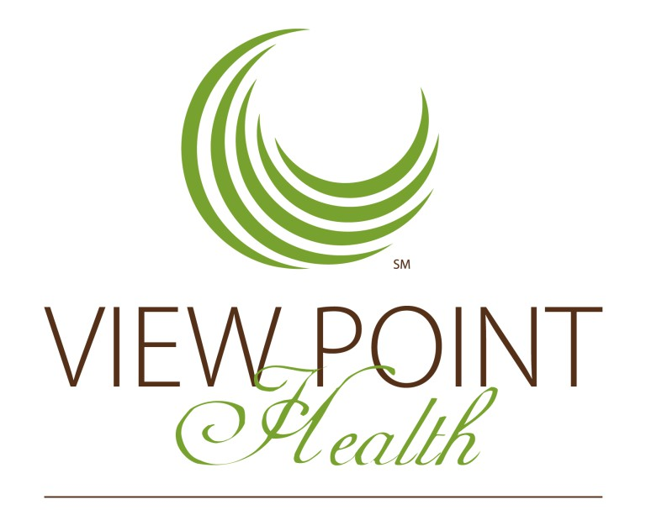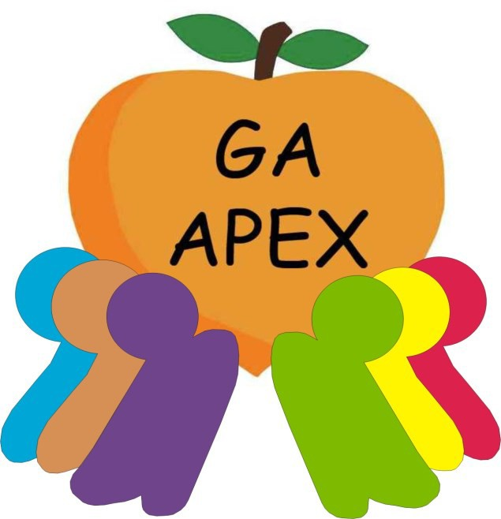



**Schools receiving School-Based MH services: Gwinnett County Schools**:

Hopkins Elementary School Lilburn Elementary School Graves Elementary School Meadowcreek Elementary School Rockbridge Elementary School Nesbit Elementary School Ferguson Elementary School Radloff Middle School

Lilburn Middle School Central Gwinnett High School Meadowcreek High School Berkmar High School

Give East Give West

Grayson High School Collins Hill High School Duluth High School Dacula High School Oakland Meadow

**Rockdale County Schools**:

Pine Street Elementary School

J.H. House Elementary School Conyers Middle School **Newton County Schools**: Middle Ridge Elementary School Clements Middle school

Indian Creek Middle School Cousins Middle School Liberty Middle School Veterans Middle School Newton High School Alcovy High School

Career Academy High School

Eastside High School

Rise Academy

**DeKalb County Schools:** Tapestry Public Charter School **Buford Schools:**

Buford Middle School

Buford High School



***Welcoming***

*“Services were available at times that were convenient for us.”*

***Trust***

*“I felt my child had someone to talk to when she was troubled.”*

***Support***

*“I helped to choose my child’s ser-*

*vices.”*

***Results***

*“My child is better able to cope when things go wrong. The people helping my child stuck with us.”*

*(Above quotes are from VPH youth*

*services)*

|  |
| --- |
| ***“Cultivating Our Future”***  School*-*Based  Mental Health  Services |
|  |
| *myviewpointhealth.org 678-209-2326*  [*youthservices@vphealth.org*](mailto:youthservices@vphealth.org) |

VIEW POINT HEALTH SCHOOL- BASED MENTAL HEALTH SERVICES OFFERS….



**What is the GA Apex Program?**

Is a state funded program dedicated to provide school based mental health services.

**Why School-Based Mental Health?**

* Providing early detection, intervention, and prevention improve and increases overall academics success and

promote mental and emotional health

* Schools are the foundation of the communities
* Convenient for parents and guardians without access to transportation
* Increased collaboration between View Point

clinicians, community and the schools.

* **Assessment-**conducted by a qualified and licensed clinician. The client and family’s goals are identified and an individualized treatment plan is developed.
* **Goal Attainment -** Students meet one-on-one with a clinician to learn and practice emotional regulation, social skills, problem solving strategies, relationship skills, and anger management. Each child and their family sets their own goals to work on with their treatment team.
* **Family Involvement and Support -** Families are welcome and encouraged to attend sessions with their child at the school! Topics covered include parenting skills, communication, managing difficult behaviors, nutrition, children’s sleep, and building children’s self-esteem.

ADDITIONAL SERVICES

* **Group counseling**
* **Tele mental Health Counseling**
* **Individual Counseling**
* **Family Counseling**
* **Access to psychiatry and nurs-**

**ing services**

* **In home community support**
* **Faculty consultations**
* **Community Resources**

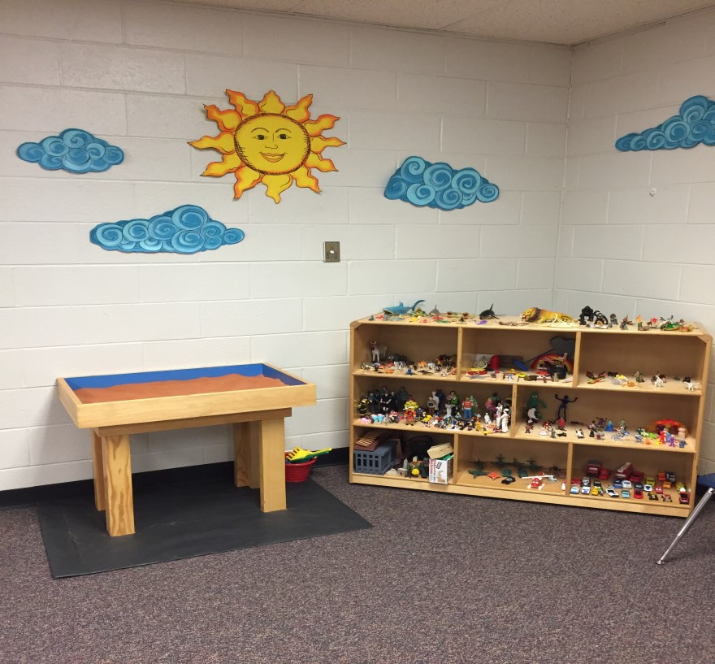

* + Ask your school’s counselor for

more information.

* + - No insurance, no problem!